# Exp4 Objects and Classes

**1 Experiment purpose**

Through this training, to make the students skilled in the use of class, object, inheritance, polymorphism to programming. To understand the definition of class, the definition of an instance variable, the definition of the method, the difference between the formal parameters and the real parameters, and the method of the parameters in the Java language. To understand abstract classes and interfaces and grasp how to program with them.

**2 Development Environment**

1. Notepad++
2. JDK 8+

**3 Content and Steps**

**Problem 1:** Design a ***gobang*** *(or Five in a row)* game

The objective of the experiment is to design and implement a ***gobang*** game.

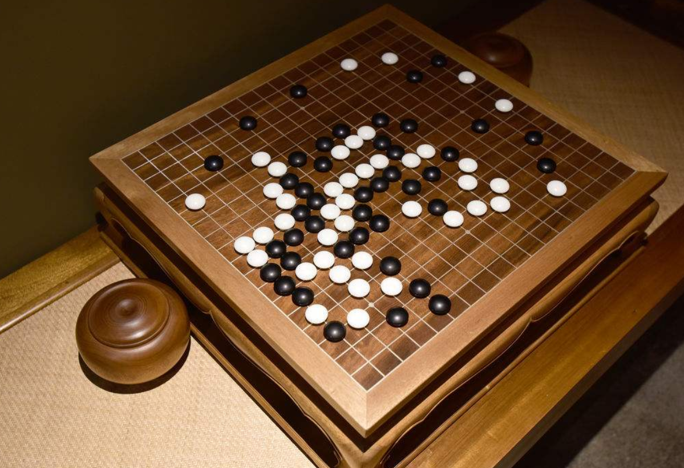

**Steps:**

1. Define the client class and design the main business processes.

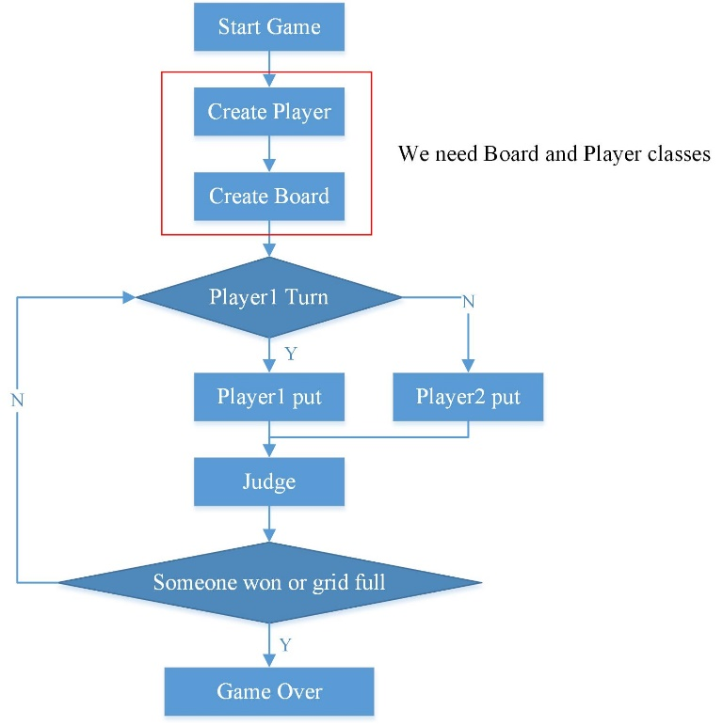

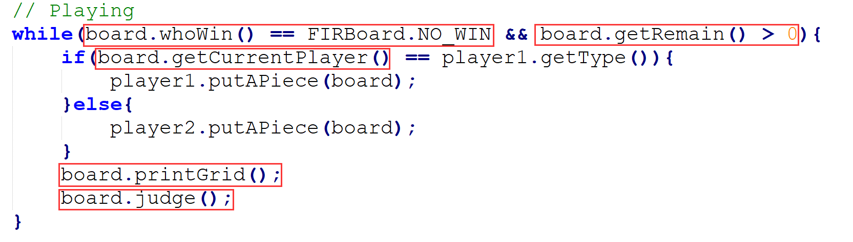

2. Define and design the board class.

(1) Define the board class and its data field

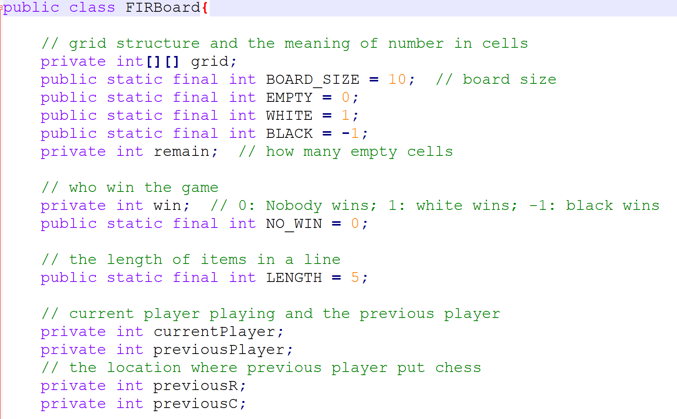

(2) Design and implement the contructor method

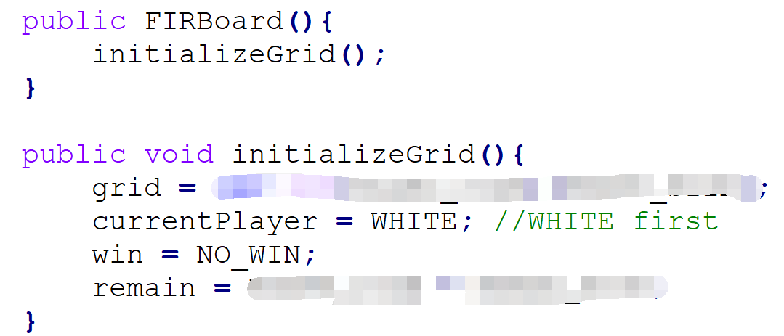

(3) Design and implement the printing method



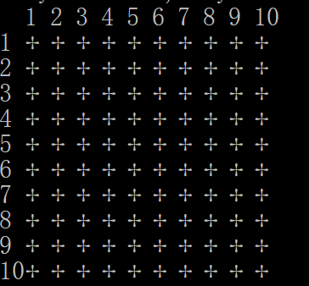

(4) Implement some getter methods

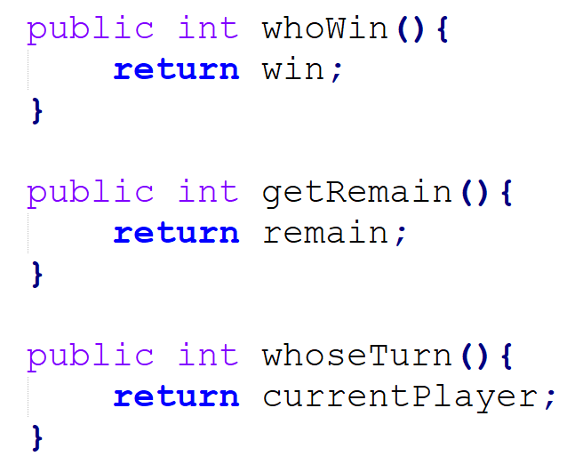

(5)Design setChessPiece method.



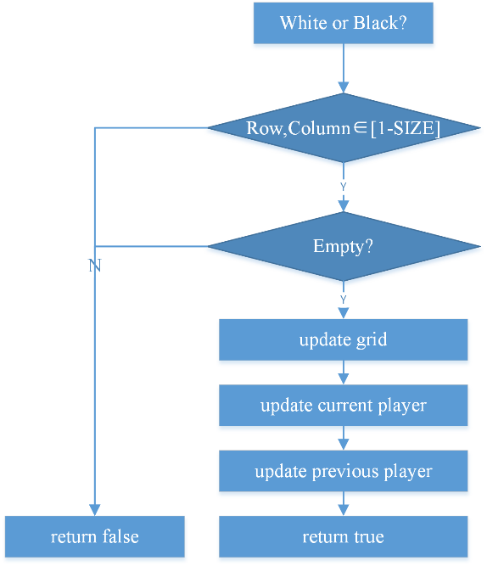

(6)Implement judge() and extract() method

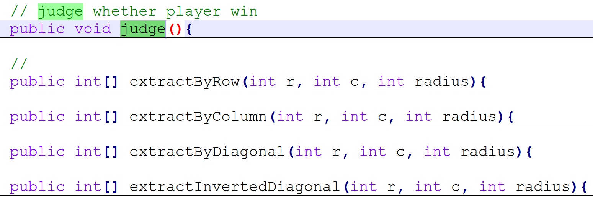

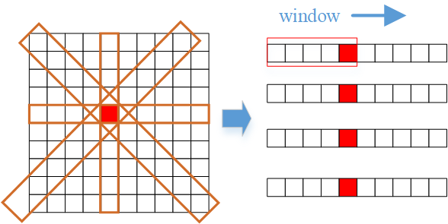

3. Define and design the player class.

(1)Define the class and constructor

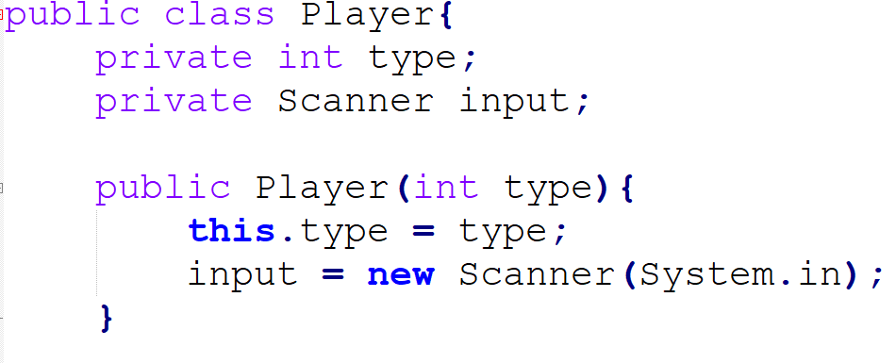

(2)Provide a method for name translation

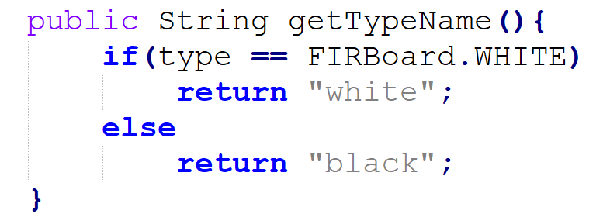

(3)Design the putAPiece() method

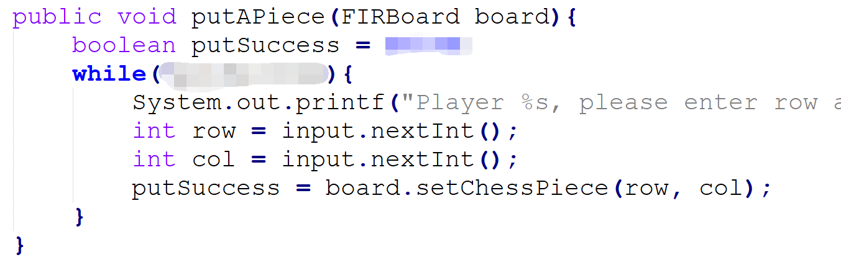

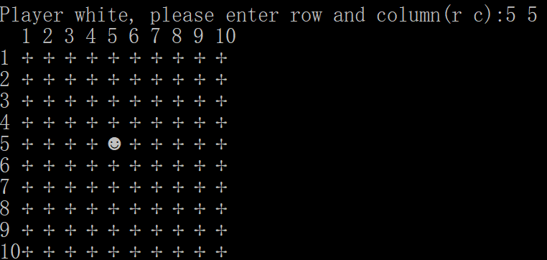

4. Running and test the program.

(1)Open a cmd and compile the program.

javac -encoding utf-8 FIRClient.java



(2)Open another cmd, set Unicode page and run the program.

chcp 65001

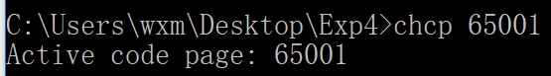

java -Dfile.encoding=UTF-8 FIRClient



